AL JOHNSON ART

2248 Birch Street, Easton PA 18042 (home), 1120 Butler Street # Easton Pa, 18042 (studio)
646-963-0498 (cell) al.aljohnson@gmail.com, www.aljohnsontheartist.com

Education
Pratt Institute Brooklyn, New York, 1976
Arts Student League, 1978
Military Service, Honorably Discharged 1982
Residencies: Rush Arts 2016-2018, The Banana Factory 2018-2021

Professional Experience
Illustrator (1983-1986)
Design artist for J. Walter Thompson and Grey Advertising Agency.
Layout and design artist for Woodward and Lothrop stores and the Washington Post.

Storyboard Artist
1989– 2024 Storyboard for advertising agencies, commercial and film productions.
2014 Feature Film Fate by director Jonathan Baker, Paramount Pictures.
2006 Feature Film The Fountain by director Darren Aronofsky.
1999 Oscar© Winning Film The Hours by director Stephen Daldry.
1989 Feature full-length films by MGM studios, Morgan Creek, and major ad agencies.

Teaching Experience
2023 World Trade Center Oculus, The Cross Culture Project Exhibition, and Interactive Experience.
2009 Management proctor at Chashama Studios . Managed studio operations for 31 artists and curated exhibitions.
2006 - 2008 Opened Al Johnson Art Studio in Brooklyn NY. Established the Al Johnson mentoring program, teaching budding artists from the ages of six to sixty. Served as a substitute teacher for NYC Board of Education.

Exhibitions
Solo Exhibits

2023 “Intuitive Visions” Palmer Art Gallery Larchmont, NY
2021 “In Your Dreams”, Joyce Gordon Gallery, Oakland, CA.
2019 “Interpretizm”, Rush Art Philly Gallery, PA.
2019 “Dream Portal: Gateway to Painted Imaginations,” Holtzman Gallery, Atlantic City, NJ.
2018 “Cross Culture Abstraction”, Church Street Gallery, West Chester, PA.
2016 La Maison d’Art Gallery, Port Barcares, France.
2015 “Cosmosis”, South Orange Performing Arts Center, NJ.
2015 “The Room of Wonders”, La Maison d’Art Gallery, NY.
2010 “Artist DNA”, Chashama Gallery, New York, NY.
2005 “Cross Culture, the Exhibition”, Saga Art Gallery, Sonoma, CA.
2003 Heather Edelman Gallery, New York, NY.

Group Shows
2024 – 2025 “Changing the Face of Democracy” Museum of the City of New York,
New York, NY. (Opens Summer 2024)
2023 Bethlehem House Gallery, Bethlehem, PA.
2023 “Blackity Black” Navodo Gallery, Jersey City, NJ.
2022 Harlem Fine Arts Show, Washington DC.
2021 Carter Burden Gallery, New York, NY.
2021 The Art Trust, Gallery of Meridian Bank, Westchester, NY.
2021 Harlem Fine Arts Virtual Exhibition.
2021 Integrated Art Group, Madison, WI.
2020 Bethlehem House Gallery, Bethlehem, PA.
2019 “I Kan Do Dat” Exhibition, Rush Art Philly Gallery, PA.
2019 X Gallery, New York, NY.
2019 Allentown Museum, Allentown, PA.
2019 Church Street Gallery, Westchester, PA.
2018 The Tiberino Museum, Philadelphia, PA.
2018 Rabbit Hole Gallery, Philadelphia, PA.
2018 Allentown Museum, Allentown, PA.
2018 Bethlehem House Art Gallery, PA.
2018 Group exhibition, Malverne Retreat House, Malverne, PA.
2018 Miami Art Basel, Rush Art Philly Gallery, Miami, FL.
2017 –2018 In Liquid Group Exhibition, Philadelphia, PA.
2017 “Reflections of Monk”, Kenkeleba Gallery, NY.
2017 “Painted Bride”, Rush Art Philly Gallery, Philadelphia, PA.
2017 Collectors Cocktail Ball Exhibition, “In Liquid”, Philadelphia, PA.
2017 Art on the Hamptons
2017 Allentown Art Museum Group Exhibition, Lehigh Valley, PA.
2017 Malverne Retreat House, Malverne, PA.
2014 “We Can do Dat,” Rush Arts Chelsea Gallery, NY.
2010 Guangzhou International Art Fair, China
2009 “Art and Literature-The Multi-Media Dream,” Brazilian Foundation for the Arts, NY.
2009 “Pulse,” Taller Boricua Gallery, NY.
2009 “Innervision of Hope”, The International Center, NY.
2009 Jacob Javits National Fine Art Show, NY.
2009 National Black Fine Art Show, NY.
2008 General Electric’s Corporate Headquarters Cultural Fine Art Gallery, Stamford, CT
2007 Tom Joyner Foundation Cruise, Miami, FL
2006 “Art on the Main”, Puck Building, NY
2005 32nd Juried Exhibition, Pleiades Gallery, Jordan Kantor, Curator, NY.
2004 Museum of Contemporary African Diasporan Arts (MoCADA), NY.
2003 Susan Benton Gallery, NY.
2003 Heather Edelman Gallery, NY.
2002 Rush Fine Art Gallery, NY.
2001 Artist Loft Exhibition, NY.
2000 University of Rochester, NY.
1998 Tokyo Metropolitan Art Museum, Japan.
1996 African Museum of Art, NY.
Commissions and Awards
2016 Commissioned painting by the Government of Port Barcares, France.
2013 First Lady Michelle Obama graciously accepted the Al Johnson original painting “The Arrivals” at the LGBT Leadership Council of the Democratic National Conference. Accompanying this painting was an original poem written by Mr. Johnson's 89-year-old mother.
2012 Named as one of the top 50artists of the LeRoy Neiman Center for Art.
2012 Named Bearden 100 artist in celebration of Romare Bearden’s Centennial.
2008 Bedford Stuyvesant, New York YMCA “Energy Tiles” Permanent Installation.
2006 Commissioned by the Shirley Chisholm Cultural Institute Inc. to paint the portrait of Shirley Chisholm which hangs in Brooklyn Borough Hall. Listed in the Smithsonian National Portrait Gallery Catalog of American Portraits.
2004 Paints portrait of Shirley Chisholm which becomes the United States Postal Service marquee for the Shirley Chisholm Bedford Stuyvesant Post Office.
1996-1998 Commissioned to create the art rendering for the Georgia Aquarium, formerly the largest aquarium in the world.

ARTIST STATEMENT

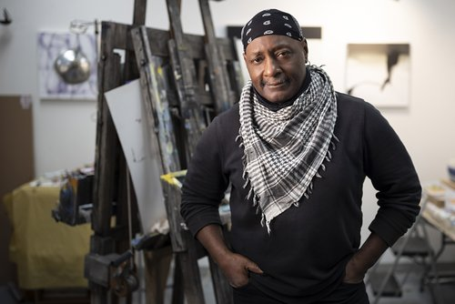

“A large portion of my work stems from my experience working in commercial illustration and film production. For years, I have been hired to create imagery that tells a story. In fusing talent and imagination, my art is a medley of poetic gestures. The viewer will see abstraction, surrealism, and cubism done in a myriad of styles in mixed media. The purpose of my method is to offer a portal to introspection. Each piece in its inception has a story of my spiritual journey and the viewer’s personal connection to its creation.”
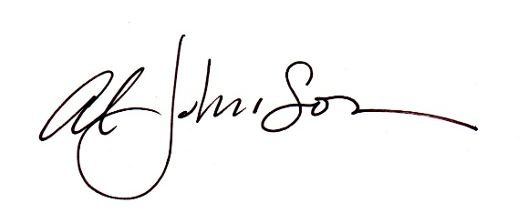

AL JOHNSON ART

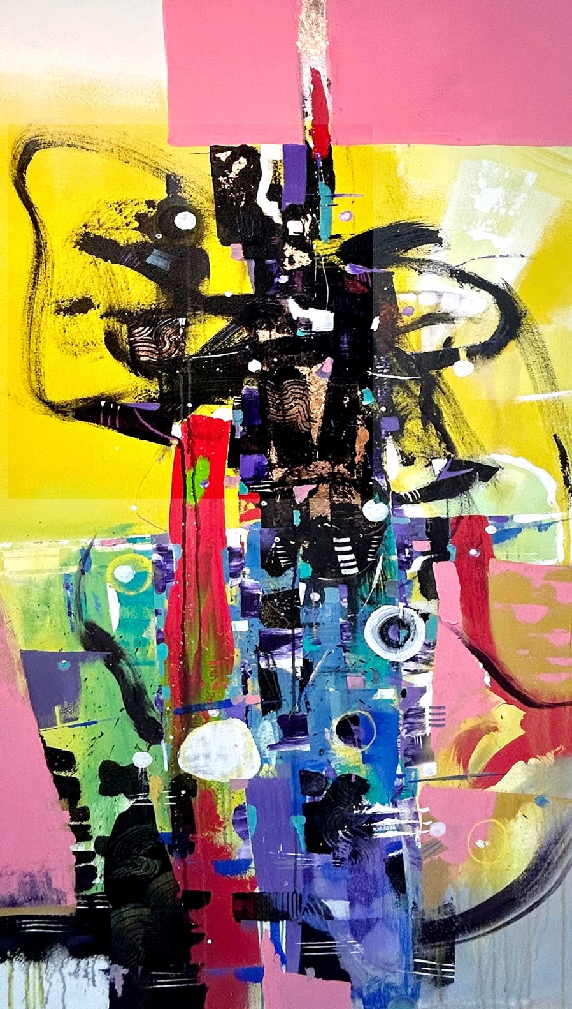

”Go Save The World”
38”x 66” mixed media
on canvas 2023

AL JOHNSON ART

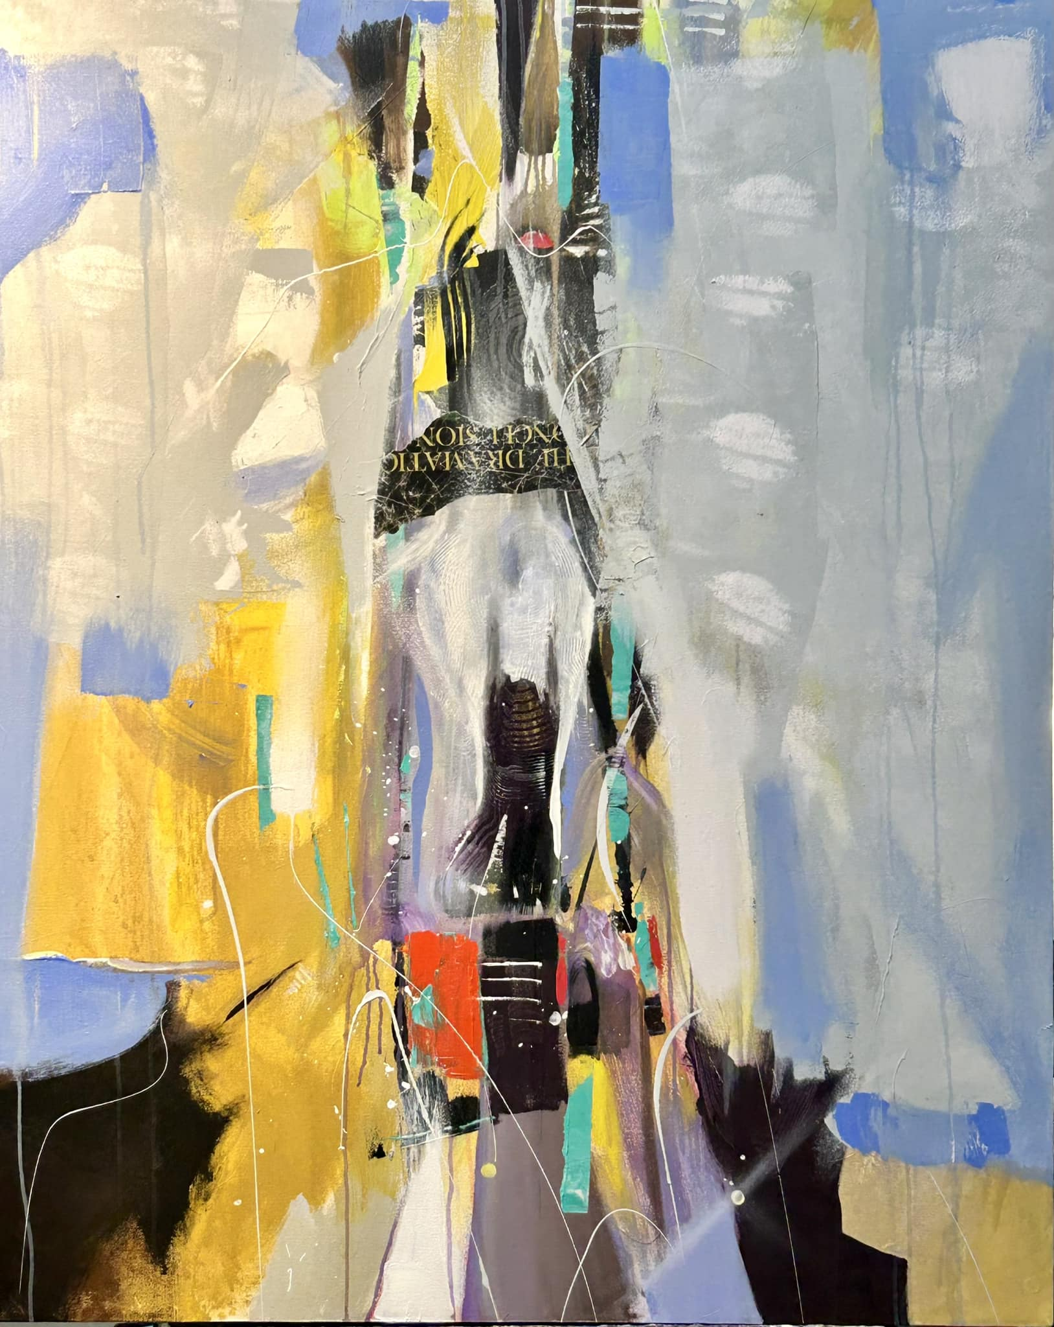

“Kisses from Spirits”
44” x 55” mixed media
on canvas 2024

AL JOHNSON ART

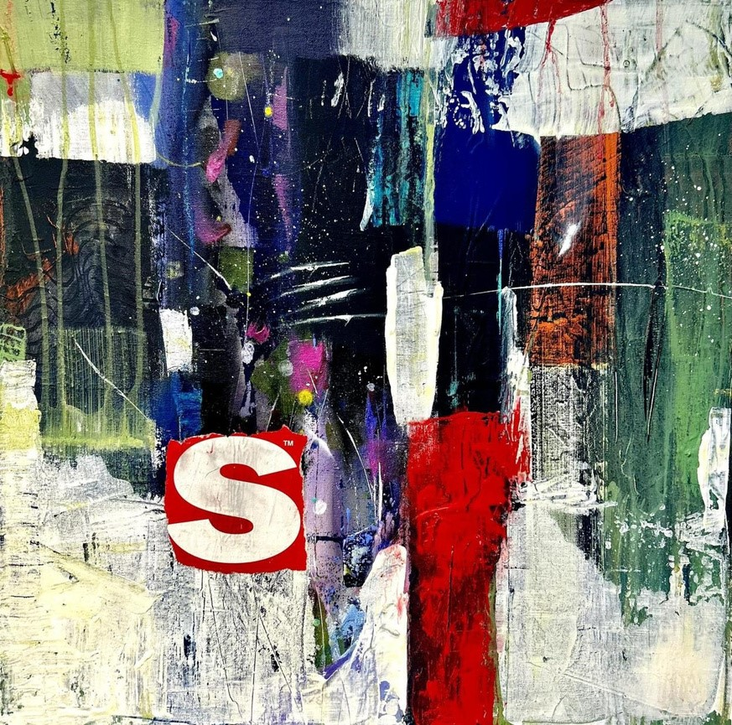

“Souls Survival”
24” x 24” mixed media
on canvas 2024

